WIREFRAME DOCUMENTATION

# INSURANCE PREMIUM PREDICTION

By- Jay Telgote

iNeuron

## Web Interface

The first thing as they click on url is this pop up window on Homepage, which will ask for user to input details of their physiological features.

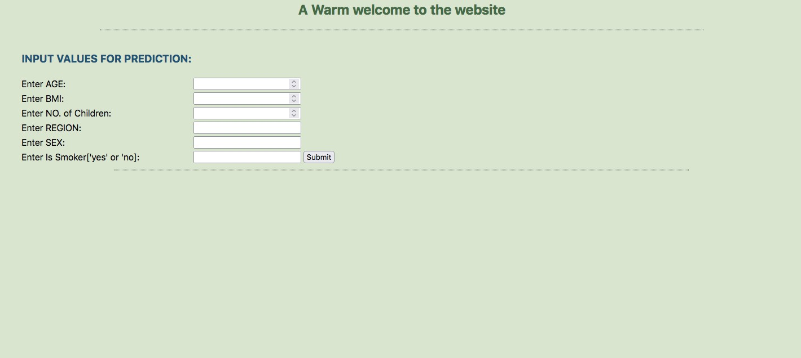

## User Input

Here as one can see there is dropdown for every input selected by the user. An example is given here wherein we have input the necessary values in the boxes given below.

Once all the boxes have been filled, you need to click on the submit button.

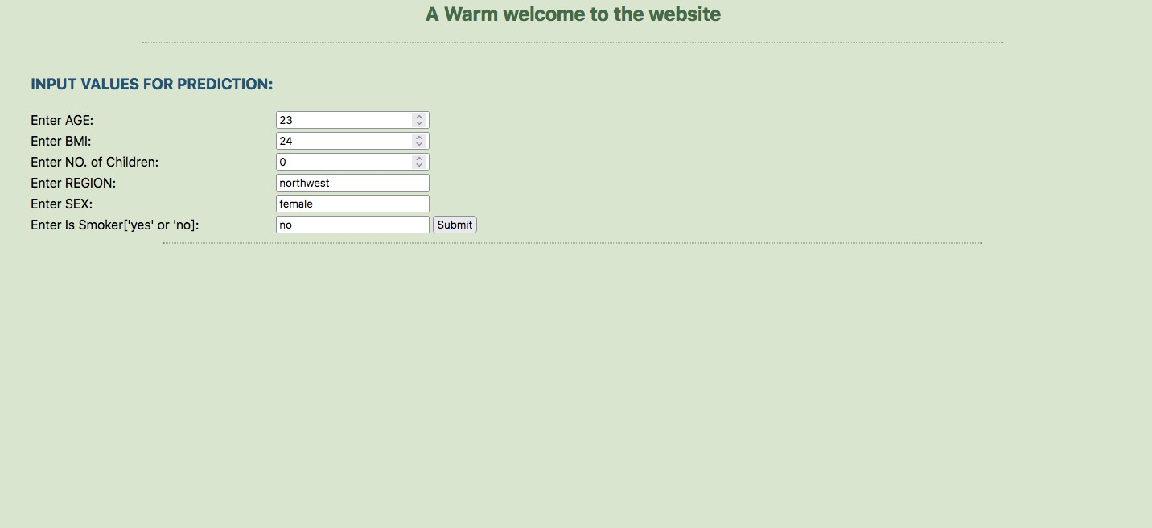

## Result Page

As you can see the output has been predicted by the machine learning algorithm, and the result has been displayed in the frame below.

